13.6 Tech Form 6: Format for Biodata of personnel
Name |  | Years of Exp |  |  | Proposed Position
Shourjya Ghosh |  | 11 Years 8 months |  |  | Full Stack Developer
1 | Name of Company: |  |  | Opentext(Last Company)
2 | Designation of Staff: |  |  | Lead Software Engineer
3 | Date of Birth: | 14.01.1990 |  | Nationality: |  | Indian
4 | Education: Bachelor of Technology
 | S.No | Degree Obtained |  | Institution | Dates
 | 1 B.Tech | Yes |  | West Bengal University of Technology | 31.05.2012
 | 2
 | 3.
5 | Membership of Professional Associations: |  |  | NA
6 | Other Training: |  |  | NA
7 | Countries of Work Experience: |  |  | NA
8 | Languages: | Language |  | Speak | Read |  | Write
 |  | English |  | Yes | Yes |  | Yes
 |  | Kannada
 |  | Hindi |  | Yes | Yes |  | Yes
 | Employment Record: | From/To |  | 06/2023 to 03/2026
 |  | Employer |  | Opentext
 |  | Position Held |  | Lead Software Engineer
 |  | From/To |  | 11/2021 to 06/2023
 |  | Employer |  | Amadeus Software  labs
 |  | Position Held |  | Software Development Ebgineer 3
 |  | From/To |  | 09/2019 to 11/2023
 |  | Employer |  | Manhattan Associates
 |  | Position Held |  | Senior Software Engineer
10 |  | Java, Spring Boot, Java backend development, Distributed System, Microservices
 | Skills
11 | Work Undertaken that Best Illustrates Capabilities to Handle the Tasks Assigned:
 | Name of assignments or projects: |  | Implementing Optical Character Recognition
 | Year: |  | 2024 to 2025
 | Location: |  | Bengaluru
 | Client: |  | Opentext Clients
 | Main project features: |  | Enabling automated  handwritten text recognition on scanned documents, improving document processing accuracy by 55%  and reducing misinterpretation of handwritten English text to below 5%, eliminating manual transcription  bottlenecks.
 | Positions held: |  | Architect and implementor
 | Activities performed: |  | Architected and integrated OpenText Aviator AI Engine
 | Name of assignments or projects: |  | Implementation of CPaaS(Communication Platform as a Service) workflow.
 | Year: |  | 2023 to 2025
 | Location: |  | Bengaluru
 | Client: |  | Opentext Clients
 | Main project features: |  | This SaaS  application unified in-house communication channels (SMS, Voice, WhatsApp, Email) into a highly scalable  platform using workflow management via Temporal to serve enterprise customers.
 | Positions held: |  | Architect and implementor
 | Activities performed: |  | Led end-to-end architecture and development
 | Year:
 | Location:
 | Client:
 | Main project features:
 | Positions held:
 | Activities performed:
 | Year:
 | Location:
 | Client:

Certifications :

I, the undersigned certify that:

(i) to the best of my knowledge and belief, this bio data correctly describes me, my qualifications,
and my experience.

I understand that my willful misstatement described herein may lead to my disqualification or dismissal, if engaged.
Shourjya Ghosh
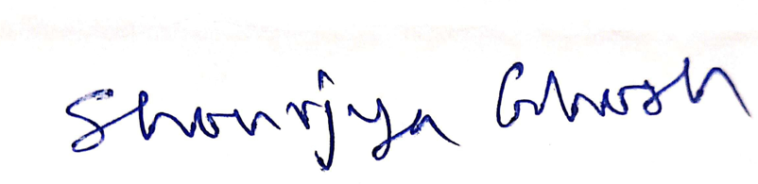
Name & Signature (Personnel) Name & Signature (Authorised
Representative)
Bengaluru, 26.05.2026
Date and Place of signing Date and Place of signing

